Elementary Humanities – History and Literature of the United States
3708

Readiness Assessment Test

Thank you for considering this course for your student. Here are some tips for success in the Readiness Assessment process.

- Please do not provide your student this assessment or its contents until you are ready for him or her to complete it in a single sitting with no books, notes, or outside help. It is intended to be a spot check of retained knowledge and skill.

- Make sure you have the latest version of this assessment. Ideally, please download it and have your student complete it within one week prior to enrollment.

- Completed Readiness Assessment materials for a course should be submitted immediately after you enroll in the course.

- Readiness Assessment materials must be submitted by uploading from the Family Account in the Enrolled Courses view. Readiness Assessment materials are not accepted through email.

- Visit Live Chat, or email TPS Support (support@pottersschool.org) for questions or assistance.

Part I: Academic Background (to be completed by the parent)

Age/Grade
- How old will your student be as of October 1st of the academic enrollment year?

- What grade will your student be in at the start of this course?

Related Coursework
- Please provide the title of the most recently completed (or in-progress) course in the same subject area or related subject area that might help assess academic readiness for this course:

Course Name:

  - What is the student’s in-progress or final course grade?

  - What is the name of the course provider (e.g., taught at home, local co-op class, online course provider)?

  - What is the name of the course curriculum (title and name of publisher of primary text if known)?

  - Is the student on-track to complete the entire course/curriculum by the end of the current year (if in-progress)?

  - How is the course evaluated? Is the work self-checked, parent-checked, or evaluated outside the home?

Additional Background

- Is your student’s first language English or a different language? If different, what is his or her language background? (Note: Most TPS classes are designed for native English speakers, but we also provide support at several levels for students whose first language is not English.)

- Is there additional information that might help us better know your student and understand his or her unique abilities and needs for the best course placement and academic outcome?

Part II: Readiness Test

Student Writing Samples: (without help from an adult)

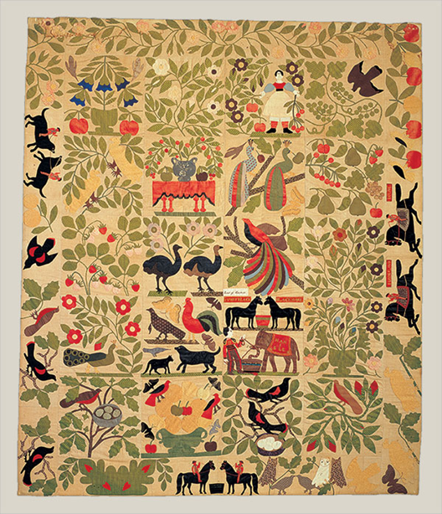

Birds of Paradise -- Artist Unknown

Non-fiction:
Below, please have your student write a short 2-4 paragraph non-fiction writing sample. You may also have them re-type a composition they wrote recently.

Fiction:
Below, please have your student write a short 2-4 paragraph fiction writing sample. You may also have them re-type a composition they wrote recently.

Part III: Student Questionnaire (to be completed by the student)

- What are the last three books that you read by yourself?

- What is your favorite part about reading?

- What do you like and dislike about writing?

- Is there anything else that I should know about you that would make your time in this class more successful? (challenges, needs…)

